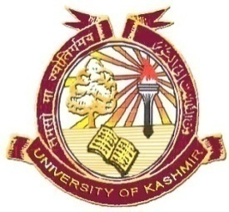
Department of English
University of Kashmir
NAAC Accredited Grade- ‘A+’
Phone: (O) 0194-227Extn: HOD-2332, Office-2333
(M) 0-9906523958
Professor Lily Want Email: lilywant@yahoo.co.in
Head

No: F (Eng- DIQA Information) KU/20
Dated: 06-02-2020
Director
DIQA
University of Kashmir
Srinagar.

Sir,
This has reference to the Circular No. F(Circular-DIQA information)Acad/KU/20 dated: 27-01 2020. In this regard, kindly find the desired information as under.
- The courses that focus on employability/ skill development are:
- Introduction to Linguistics:
This course helps students develop a conscious scientific knowledge about language in general and English language in particular which ultimately helps them to become effective language teachers.
- English Language Teaching:
The focus in this course is on imparting practical knowledge which helps students in their role as teachers of English at various levels.
- Value added optional courses:
- English Communication Skills-I
This course, meant for students of other departments, gives them enough opportunity to hone their proficiency in various communication skills and become effective speakers, readers and writers of the English language. It adds to the value of the M A programme in their parent department.
- English Communication Skills-II
This course, meant for students of other departments, focuses on the most important communication skills in English. Student-centric, the course adds to the value of the M A programme at their parent department.
- English for Specific Purpose
This course, meant for students of other departments, focuses on the use of English in various situations and for varied purposes. Students from diverse streams are taught important communication and writing skills keeping their needs in mind. It is a value-added course for students of other departments.
- Literature and Media
This course, meant for students of other departments, focuses on the interdependence of literature and media. Students find an applicability of this course in various academic and industry-based vocations.

Professor Lily Want
Copy to:
- Assistant Registrar, ACADEMIC, University of Kashmir for information.
- File

